# Homework #1: Windows Server 2019 & SQL 2019 VM Creation

|  |
| --- |
| * This is an individual assignment, and is worth 20 points. * The due date is Saturday, Jan 23rd Midnight. * You should use the “CIS 483 HW#1-Tasks.docx” file to provide your outcomes. * Use the following naming convention: homework, underscore, last name, first initial, and extension (e.g., Homework #1_ImG.docx). If you do not follow the convention, I will deduct 1.0. * Do not use any of the sample screenshots provided as illustrations for your submission. * Do not make screenshots too small. If too small, I will deduct points. * You are not allowed to do assignment during the class. |

**(TASK #1: 5 points)** Login to the Windows Server, and take a screenshot of the first screen.

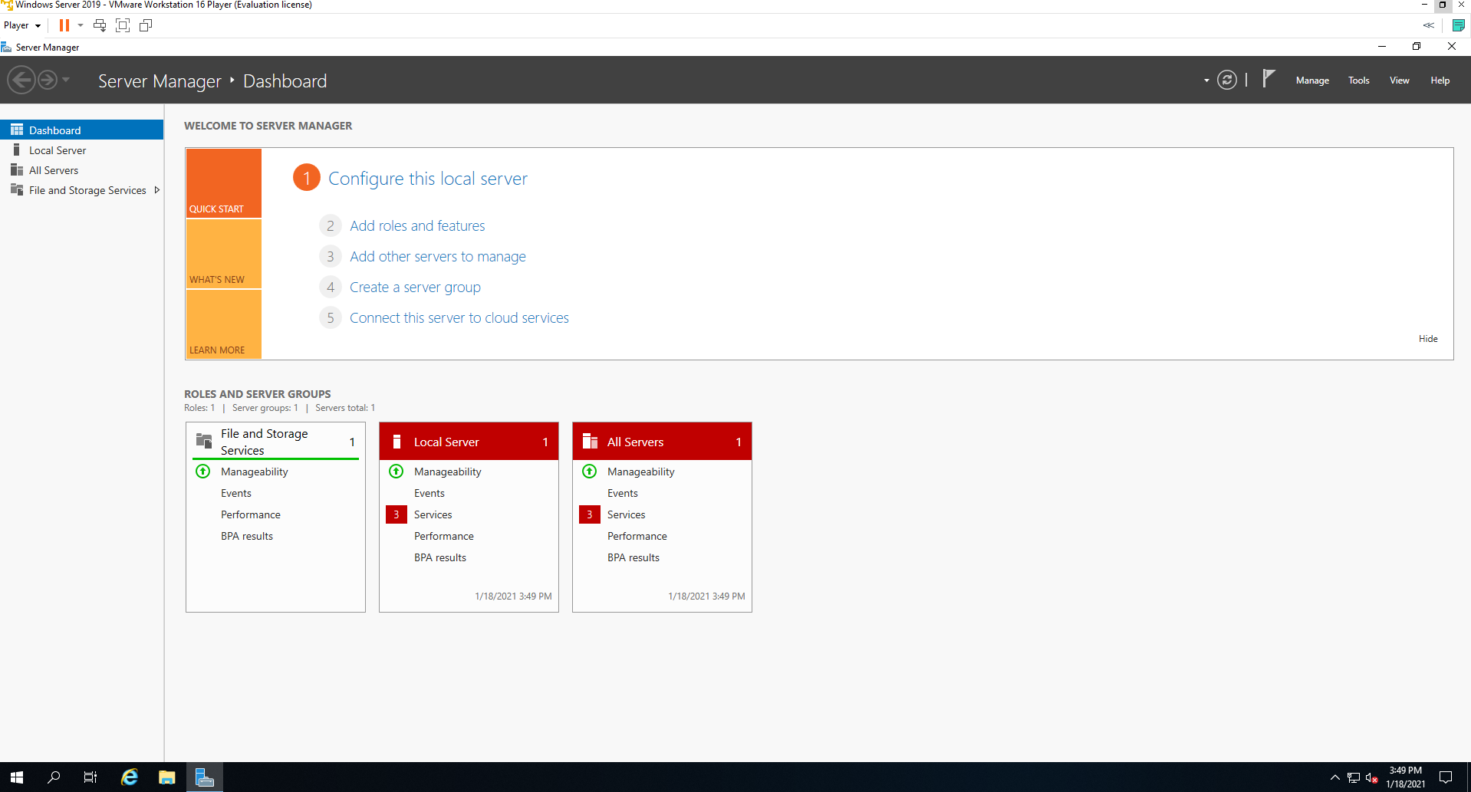

**(TASK #2: 5 points)** Run the following queries. Show the results in a screenshot. You must show that the installation is SQL Server 2019.

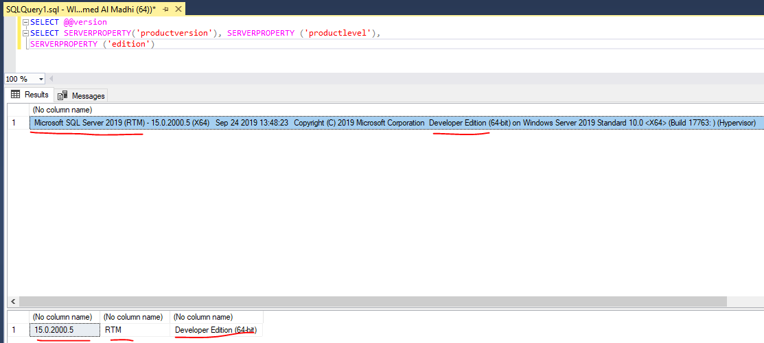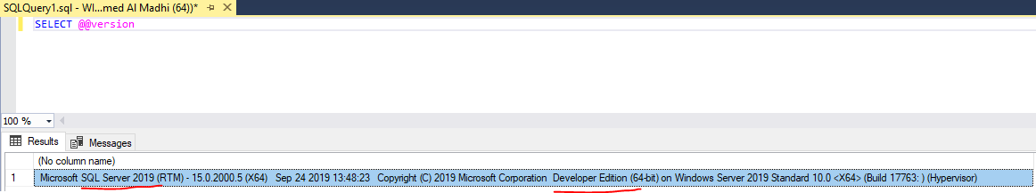

**(TASK #3: 5 points)** Show in a screenshot that the services you have installed are running.

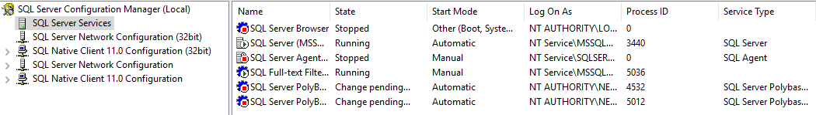

**(TASK #4: 5 points)** Execute the following query. Show the result in a screenshot. How many departments did you get with the query?

I got 16 departments.

